Report on Mimic Game

I apologise in advance for all the images of me…

# Images for reference

**B**

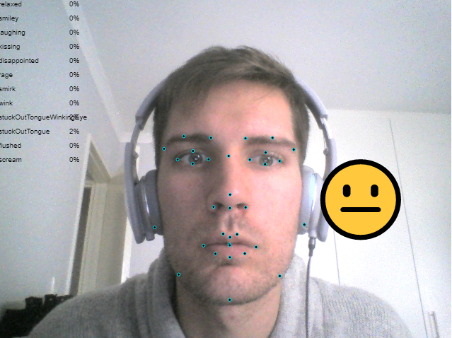

**A**

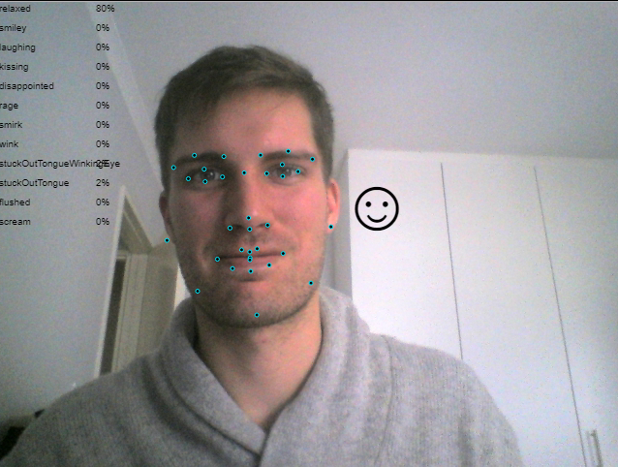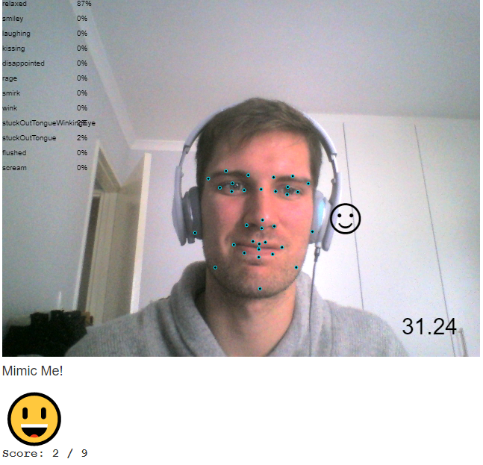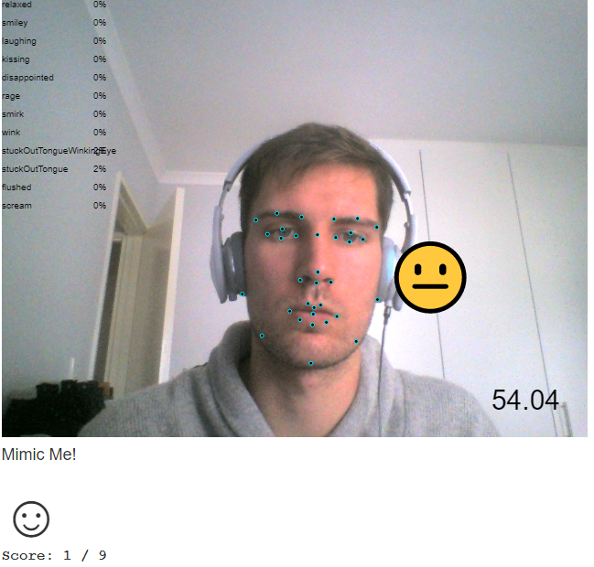

**F**

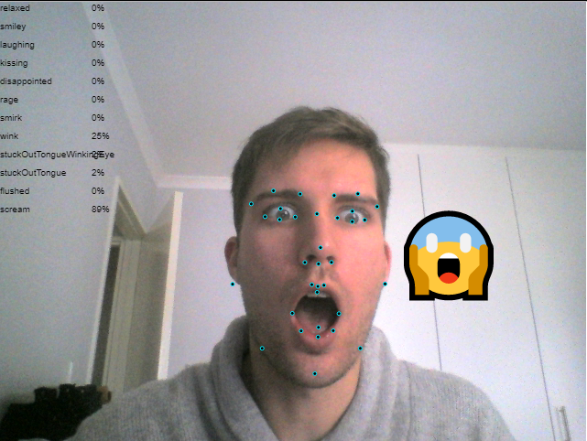

**C**

**D**

**E**

# Feature Points

* **Display feature points**: Application displays feature points as they are tracked on a face.

This is visualised as black circles with a blue stroke.

This is shown in all images A-F

# Dominant Emoji

* **Display dominant emoji**: Application displays the dominant emoji being expressed.

The dominant emoji from detector’s face.emoji object is displayed on the canvas.

This is clear in fig C.

* **Move emoji with face**: The dominant emoji is shown at a location that is close to the face, and moves with it.

The location of the emoji tracks according to the left cheek (right on the screen), shifted a bit further.

This is clear when looking at fig C and D, or A and B.

Notably, the emoji is also scaled based on size of the face (fig A and B).

# Mimic Game

* **Show random emoji to mimic**: Application shows a random emoji to be replicated by the player.

At the bottom of fig E and F are the emojis to mimic. The ‘disappointed’ face is not included in the random options. The stuck-out tongue emojis are also challenging, but are included in the random options

* **Match with current player expression**: Application correctly identifies when the player’s current facial expression matches the desired emoji.  
  On each successful face detection the current emoji and the target emoji are compared for likeness. Successfully matching increases the player’s score.

Comparing fig E and F, the score increases after the desired emoji is expressed.

**Reset and shows a new emoji**: Once the desired emoji is matched by the player, the application should pick a new one at random and the game should continue on.  
Upon successful matching of the target emoji to one’s expression, the score increases and an emoji is randomly selected from the set of random options as before.  
It is possible for the same emoji to be randomly picked twice in a row (lucky you!).   
The target emoji in E and F are different after successfully mimicking E.

A timer is shown in the bottom right corner of E and F.

The closeness to each emoji is shown on the canvas in the top left.

The scoring is shown as [current score] / [high score]

A 2-player game was implemented, but I couldn’t have the detector pick up 2 faces at one time.